Team: Javva the hutt.

Members: Rico Jaime Varenka, Márquez Sanchez Jorge Luis, Delgado Hernandez Alfonso, Mendoza Luna José Luis.

●A brief articulation of your chosen topic and rationale

Social Mobility in Mexico.

A web application with interactive visualizations of social mobility in Mexico divided by demographic indicators such as ethnicity, social economic status, age, sex among others.

What we are trying to explain it is the null social mobility in Mexico.

●A link to your data set(s) and a screenshot of the metadata if it exists.

<https://www.inegi.org.mx/programas/mmsi/2016/default.html#Microdatos>

<https://ceey.org.mx/wp-content/uploads/2019/05/Informe-Movilidad-Social-en-M%C3%A9xico-2019..pdf>

<https://www.nytimes.com/interactive/2018/03/27/upshot/make-your-own-mobility-animation.html>

●3 or 4 screenshots of relevant, “inspiring” visualizations that frame your creative fodder

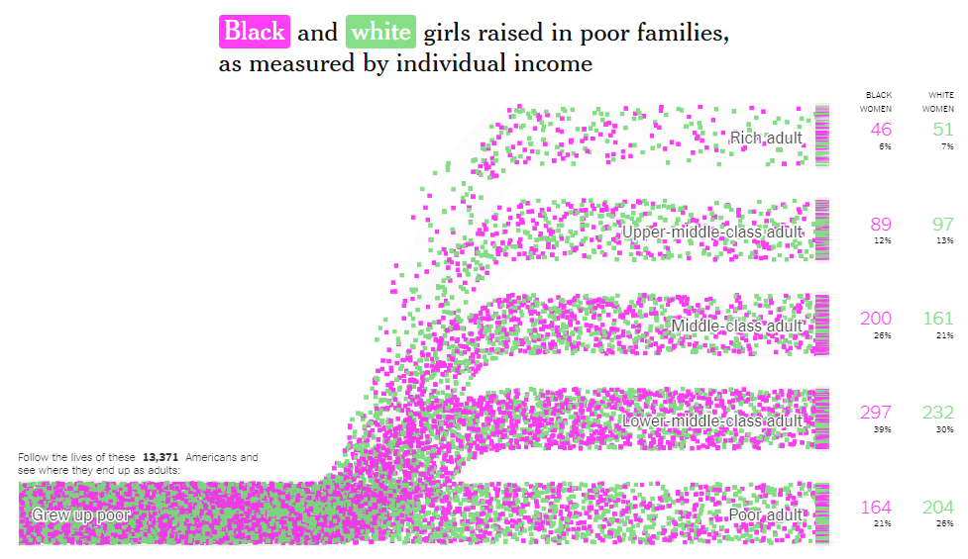

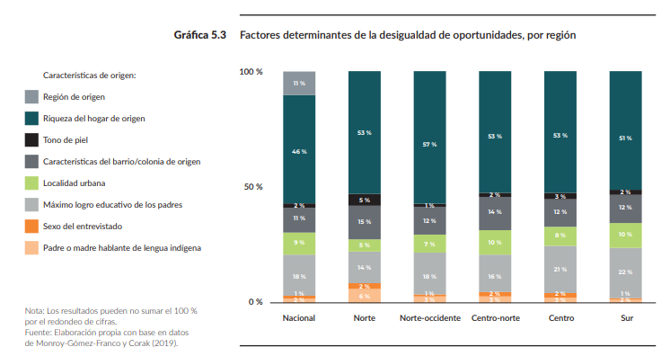

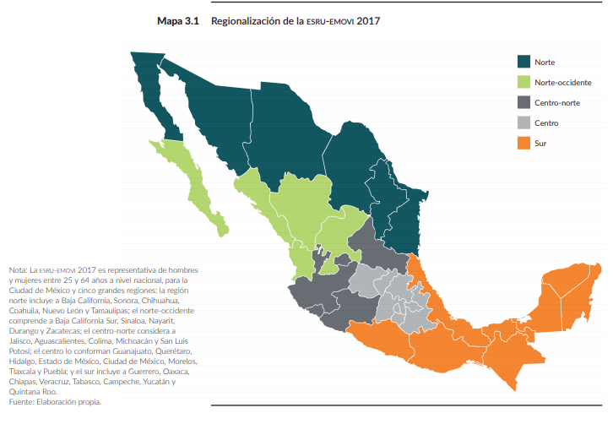

●A sketch of the final design

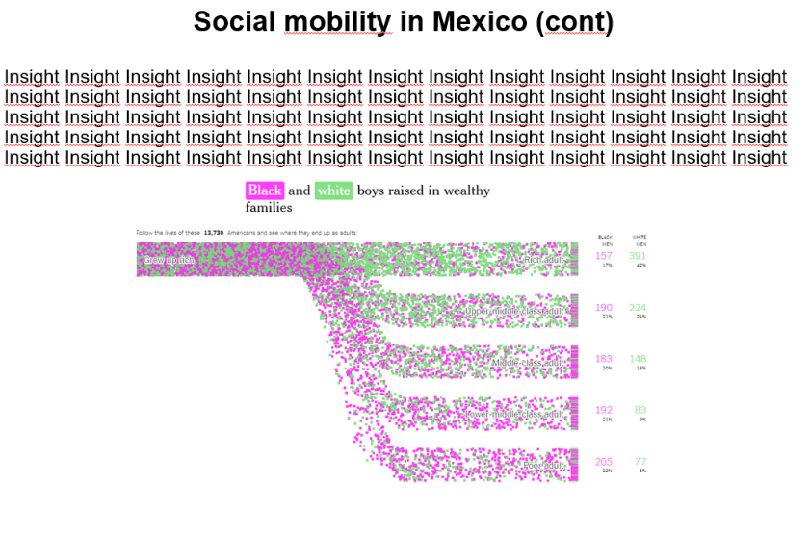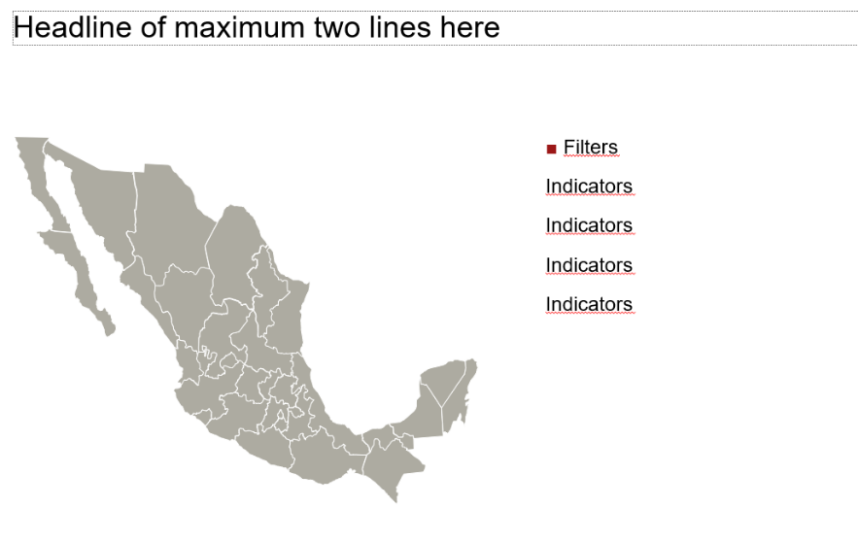

●A link to the primary GitHub repository you’ll be housing your work in

<https://github.com/jorgelmarquez94/Social_Mobility_Mexico>